**Class Assignment 6 - Relational Algebra**

Due Date: Tuesday April 16, 2019

Translate the following SQL statements into Relational Algebra:

1. Select ordernum from orders natural join salesRep where salesRep.salesLName = “Harrison”

pi orders.ordernum(sigma orders.saleslname = salesRep.saleslname ^ salesRep.saleslname = “Harrison”) (orders |X| salesRep))

1. Select ordernum, salesLName from orders ***natural*** left outer join Salesrep;

pi.orders.ordernum, salesRep.saleslname (orders salesRep)

1. Select * from Jansales

union

Select * from Febsales

union

Select * from Marsales;

(sigma Jansales) UNION (sigma Febsales) UNION (sigma Marsales)

1. Select ordnum, sum(price) from order_detail group by ordernum;

sigma ordernum (gamma sum price(order_detail))

1. Select min(qty*unitprice) as min_total, max(qty*unitprice) as max_total from order_detail;

row min(qty * price) as min_total (order_detail) row max(qty * price) as max_total (order_detail)

)You can copy from the follow symbols to your homework:

Select Operation: Sigma – σ

Project Operation: Pi - 

Renaming: Row - ρ

Union: U

Intersect: ∩

Aggregation: 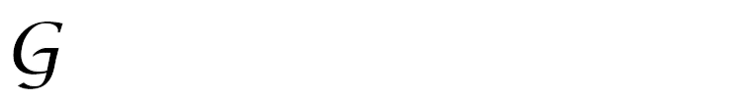

Cartesian Product: X

Natural Join:  or |X|

Left Outer Join:  or =|X|

Right Outer Join: or |X|=



(Full) Outer Join:  or =|X|=